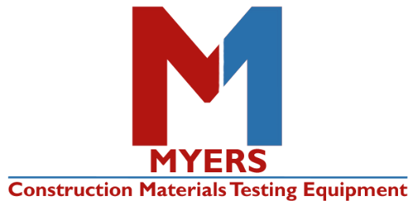
Air Meter Refurbish Form
Please enclose one form per meter

PLEASE SELECT FROM THE FOLLOWING OPTIONS:
(Check all that apply)
 | CLEAN & CALIBRATE  ($119.95 PLUS PARTS) |  | CALIBRATE ONLY ($50.00) |  | VOLUME OF BUCKET VERIFICATION (+$20.00)

FILL OUT ENTIRE FORM BELOW
Company:
Name:
Address: |  | City:
State: |  | Zip Code:
Email:
Phone:

SERIAL NUMBER OF METER:

COMMENTS (Let us know if there are any specific issues with the meter):
____________________________________________________________________________________________________________________________________________________________________________________________________________________________________________

Important Shipping Information
- Please ship just your meter only (bucket & assembly) packed in either its case or a box
- Make sure the lid of your meter matches the bucket – they should be made by the same manufacturer. If they don’t match, it can cause air leaks when calibrating and using. If you are unsure if they match, please call or email us to confirm 888.293.2121 or sales@myerstest.com
- We recommend taking the gauges off and packing with extra care to prevent damage
- Please consider shipping your meters GROUND. All New England States, parts of NY and NJ are 1 day points to us. Most other states are 2-3 day points. It will save you in freight charges by shipping ground.
Ship to Address:
Myers Associates, Inc.
21 Washington Ave
Scarborough, ME 04074

**Note: Prices above DO NOT include shipping costs**

